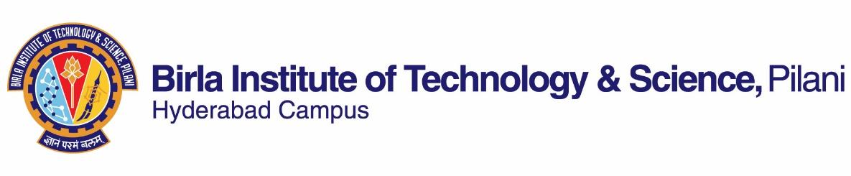

**SECOND SEMESTER 2022-2023**

# Course Handout Part II

Date: 13.01.2023

In addition to part-I (General Handout for all courses appended to the time table) this portion gives further specific details regarding the course.

*Course No.* : **PHY F241**

## Course Title : Electromagnetic Theory II

## Instructor-in-Charge : SASHIDEEP GUTTI

*Instructors*  : Sarmistha Banik, Sashideep Gutti

**Scope and Objective of the Course:**

Working knowledge of EMT is a must to be a good physicist. It is the foundation for the technologies of EE, ECE and computer engineering, spanning the entire electromagnetic spectrum, from dc to light. In EMT-I we assembled electrodynamics piece by piece and covered upto Maxwell’s equations. Now it’s time to appreciate the extraordinary power and richness of electrodynamics. We will see that Maxwell’s equations represent a fundamental unification and interdependence of electric and magnetic fields and predict electromagnetic wave phenomena. These waves move with speed of light and here we make a connection between EMT and optics. Also we study the physical phenomenon of electromagnetic radiation through Maxwell’s equations. Finally, we introduce the other major conceptual advance in electromagnetic theory i.e. Einstein’s special theory of relativity.

**Textbooks:**

1. David Griffiths, J., *Introduction to Electrodynamics*, PHI, 4th ed.

**Reference books**

1. Feynman Lectures on Physics Vol II

**Course Plan:**

|  |  |  |  |
| --- | --- | --- | --- |
| **Lecture Number** | **Learning Objectives** | **Topics to be Covered** | **Chapter in the Text Book** |
| 1-2 | Introduction and recapitulation of EMT1 | Magnetic Field in Matter*(mostly self study)*, Maxwell’s equations | (6.1.4, 6.2,6.3),7.3 |
| 3-6 | Conservation laws | Conservation of Charge, Poynting theorem, Linear and Angular momentum | 8.1, 8.2 |
| 6-15 | Electromagnetic Waves | EM waves in free space, EM waves in dielectric matter, reflection, refraction and transmission at interfaces, Wave propagation in metals, Absorption & Dispersion. | 9.2,9.3,9.4 |
| **16-25** | Electrodynamics and Relativity | The Special Theory of Relativity, Relativistic Mechanics, Relativistic Electrodynamics | 11.1,11.2,11.3 |
|  | Mid Sem | | |
| **26-28** | Seminar/Poster Presentations | | |
| **29-34** | Potentials and Fields | The Potential formulation, Retarded potentials, Jefimenko's Eqns, Lienard-Wiechert potential and fields of a moving point charge | 12.1,12.2,12.3 |
| **35-40** | Electromagnetic Radiation | Electric Dipole Radiation, Radiation from Point Charge, Radiation reaction | 10.1,10.2 |
| *14 classes* | Tutorials | | |

**Evaluation Scheme:**

|  |  |  |  |  |  |
| --- | --- | --- | --- | --- | --- |
| **EC No.** | **Evaluation Component** | **Duration** | **Weightage (%)** | **Date, Time** | **Nature of Component** |
| 1. | Midsem | 90 mins. | 30% | 17th March, 2023 | Closed |
| 2. | Poster | - | 15% | TBA | Open |
| 3 | Tutorial tests (best 1 of 2) | 45 min | 15% | tutorial hour | Closed |
| 4. | Comprehensive Examination | 180 mins. | 40% | 18th May, 2023 FN | Open |

**Consultation Hour:** TBA

**Notices:** Notices for the course will be displayed on CMS.

**Make-up Policy:** Make up will be given for only in cases of genuine sickness (hospitalization). Make up requests must be given before the test. No Make-up for tutorial tests.

**Academic Honesty and Integrity Policy:** Academic honesty and integrity are to be maintained by all the students throughout the semester and no type of academic dishonesty is acceptable. Plagiarism and copying

would be counted as academic misconduct.

**INSTRUCTOR-IN-CHARGE**